*Florida International University*

*School of Computing and Information Sciences*

Software Engineering Focus

Feature Document

User Story ID <NVOS-7 Sort and Filter Results>

**Name:** Andrew Castillo

**Team Member(s):** Andrew Castillo, Bryan Bastida

**Project:** EnvoScholar 1.0

**Product Owner(s)**: Mark Finlayson

**Mentor(s)**: Masoud Sadjadi

**Instructor**: Masoud Sadjadi

**User Story Name:** Sort and Filter Results

### Description:

As a user, I want to sort and filter the results I have obtained, so the results better matches what the I want

### Acceptance Criteria:

* User entered search query
* Database successfully return articles in display results page
* Display results page has buttons for sorting by recency
* Display results page has inputs for filtering by date range
* Correctly sorts and filters

**Use Case**

* Name: Sort and Filter Results
* Actor: User and webpage
* Preconditions: Articles displayed on webpage as well as the filter inputs/ sort buttons
* Description <Flow of events>:
  + User types search query and presses search
  + User navigated to display results page with database retrieved articles
  + User presses the Sort/filter inputs on the display results page
  + Either sorts by recency or by specified date range or both.

**Use Case Diagram**

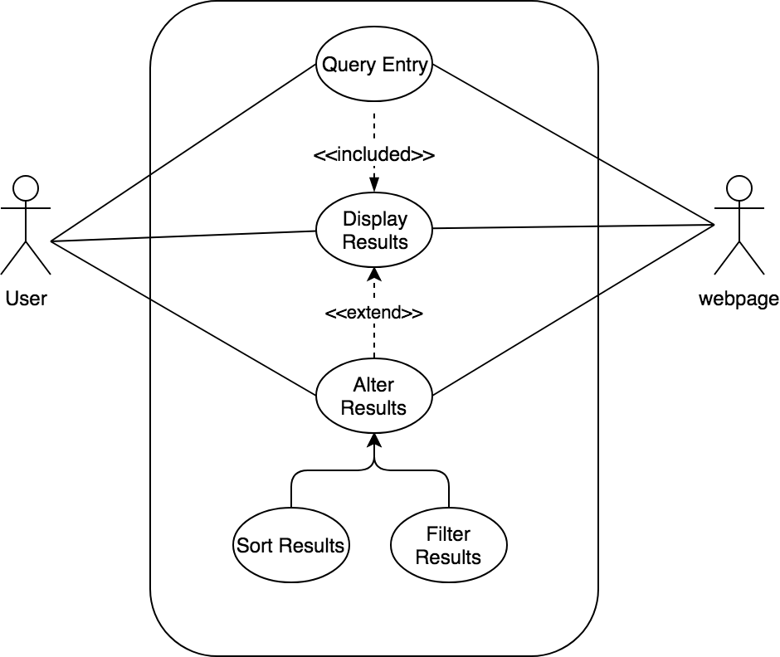

**Sequence Diagram**

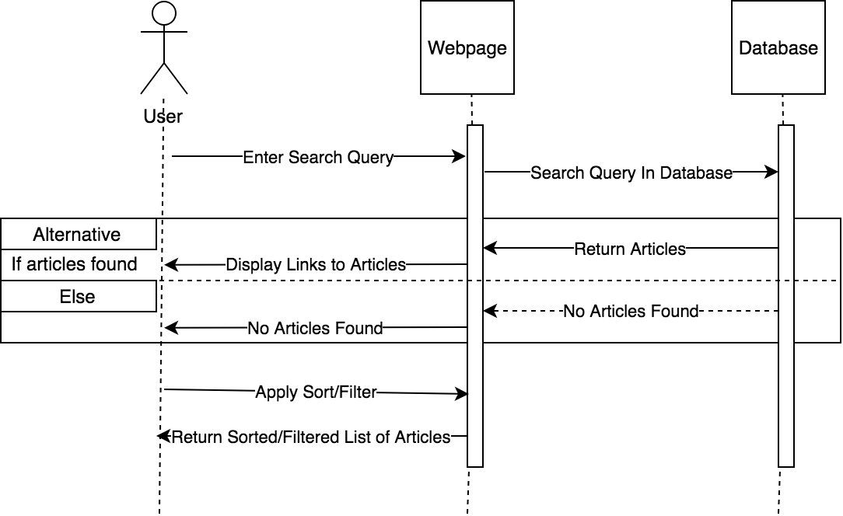

**Class Diagram**

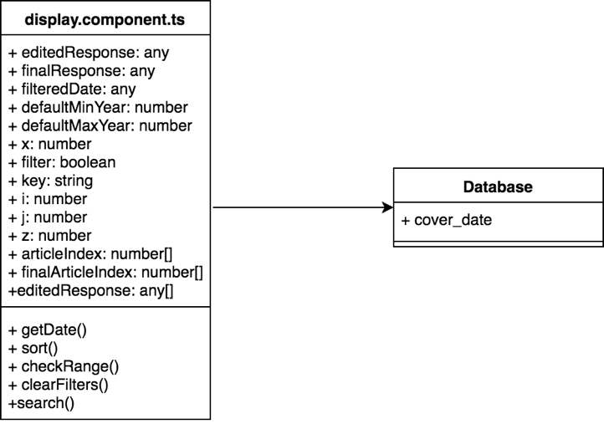

**Unit Test**

* Test case ID: NVOS-7 Sort and Filter
* Description/Summary of Test: Sort by recency and filter given date ranges
* Pre-condition: Displayed results list given a query
* Expected Results: Successful sorting and filtering
* Actual Result: Successful sorting and filtering
* Status (Fail/Pass): Pass

**Visual User Guide**

